

Placement Empowerment Program

Cloud Computing and DevOps Centre

Use Cloud Storage :Create a storage bucket on your cloud platform and upload/download files. Configure access permissions for the bucket.

Name:Manashaa U Department: CSE

Introduction:

In this Proof of Concept (POC), here I have created a cloud storage using amazon console. I have created a S3 bucket

Step-by-Step Overview Step

1)Open amazon console

2)click on create S3 bucket

3)Enter the details

4)click on “create”

5)Upload file

6)change access settings

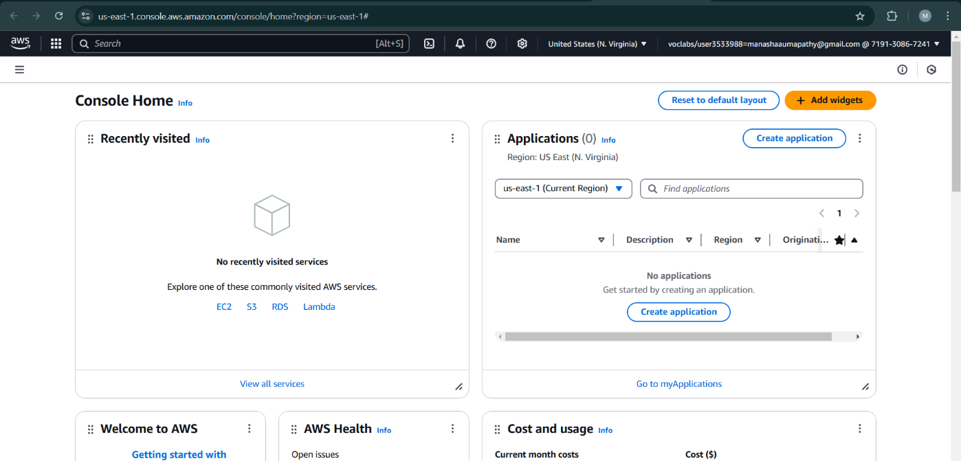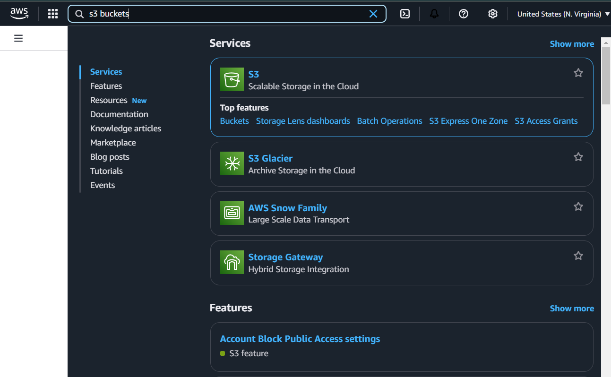

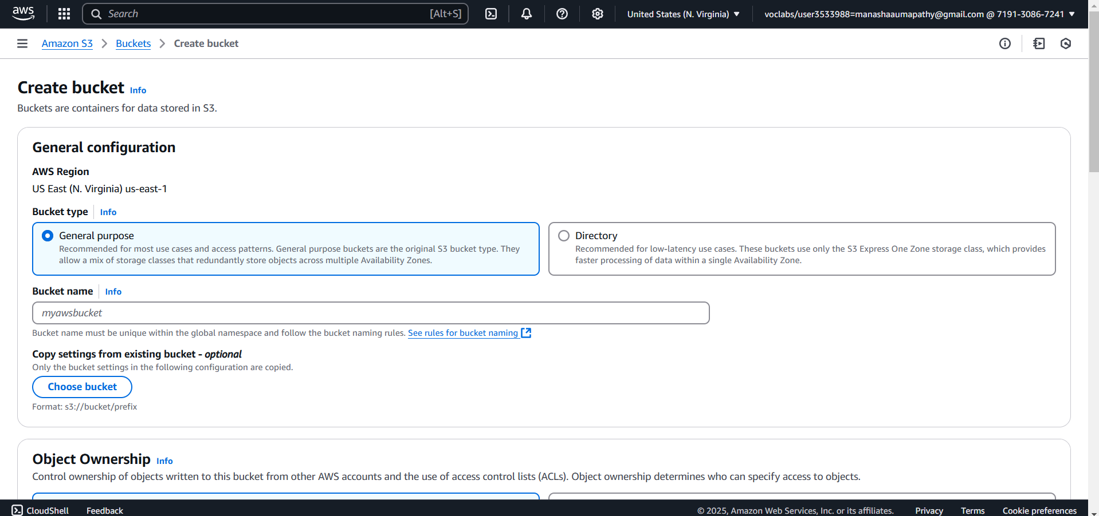

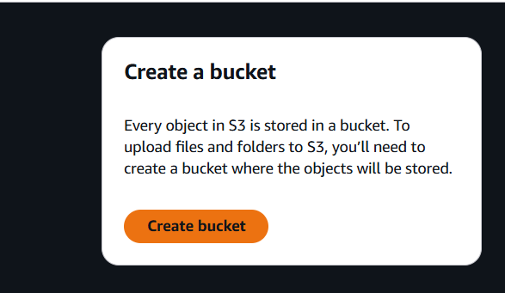

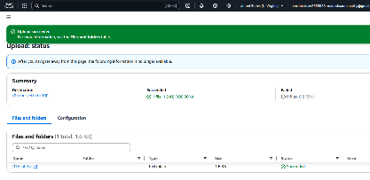

OUTCOME:

1. Cloud storage (S3 bucket) is created
2. It can store unlimited data